**KAROLINSKA INSTITUTET**

CURRICULUM VITAE

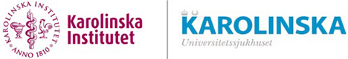

#### 1 NAME

#### Nils Peder Torbjörn Sörensson

#### 2 BIRTH DATA

#### 23 September, 1969

#### 3 ADDRESS

Work: Heart, Vascular and Neurology theme Cardiology Unit

Karolinska University Hospital Institution of Medicine, Solna

171 76 Stockholm, Sweden Karolinska Institutet (KI)

#### Recidence: Ultunavägen 18, 168 55 Bromma

#### 4 PHONE AND EMAIL

+46-731-400059

[peder.sorensson@sll.se](mailto:peder.sorensson@sll.se), [peder.sorensson@ki.se](mailto:peder.sorensson@ki.se),

**5 COURSES AND DEGREES**

|  |  |
| --- | --- |
| PhD-student at the Cardiology Unit, Institution of Medicine, Solna, KI. | 2007-2011 |
| Specialist in Cardiology and Internal Medicine | 2007 |
| Medical Doctor | 2000 |
| Medical Degree, KI, Sweden | 1998 |
| Medical school, KI, Stockholm, Sweden | 1992-1998 |
| School of Physiotherapy, Gothenburg | 1990-1992 |
| **Courses in GCP (Good Clinical Practise)** |  |
| Karolinska University Hospital, leadership course | 2017 |
| Clinical Research School, Epidemiology, Karolinska University Hospital | 2008 |
| Huddinge Research course, KI | 2006 |
| **Formal studies in university-level teaching** |  |
| Karolinska Clinical School of associate Professorship (Docentskolan) | 2020 |
| Teaching and Learning in Higher Education, distance course (GHPD), five weeks, KI | 2019 |
| Introductory Doctoral Supervision Course, one week, KI | 2014 |
| **Courses in leadership** |  |
| To prevent obstacles, Karolinska University Hospital | 2020 |
| Karolinska leadership meeting, Karolinska University Hospital | 2019 |
| Effective leadership in managing team, Karolinska University Hospital | 2017 |
| Leadership and clinical research, Karolinska University Hospital | 2017 |
| Development leadership (UL) for managers, Karolinska Hospital | 2016 |
| Value-based care, a new healthcare model, Stockholm | 2016 |
| Project Leadership for Research Group Leaders, Stockholm one week, KI | 2011 |
| Leadership training program during specialist training, five weeks, Visby Hospital, Gotland | 1999 |

**6 DOCTORAL DEGREE**

Doctor of Philosophy (PhD), Institution of Medicine, Solna, KI, 16th December 2011. “Effects of postconditioning in ST-elevation myocardial infarction: Assessment of myocardium at risk and infarct size”.

<https://openarchive.ki.se/xmlui/handle/10616/40708>

Main supervisor: Professor John Pernow, Institution of Medicine, Solna, KI

**7 POSTDOC APPOINTMENTS**

Clinical researcher, Institution of Medicine, Solna, KI, 2020-

Post-doctoral fellow, Institution of Molecular Medicine and Surgery (MMK), KI, Cardiovascular magnetic resonance (CMR) group leader, Professor Martin Ugander, 2013-2019.

**8 DOCENT-LEVEL COMPETENCE**

Application planned for spring 2021.

**9 CURRENT POSITION**

Head of Adult Congenital Heart Disease (ACHD), patientflödesansvarig/chef (PFA/PFC), Karolinska University Hospital. 2016-

Senior consultant at the Department of Cardiology at Karolinska University Hospital, Stockholm. 2012-

Clinical director, Karolinska CMR imaging group at Karolinska University Hospital, 2012-

**10 PRIOR POSITIONS**

Specialist in Internal medicine and Cardiology at the Department of Cardiology at Karolinska University Hospital, Stockholm. 2007 - 2011.

Resident physician, Department of Cardiology at Karolinska University Hospital, Solna. 2002 - 2007.

Resident physician, Department of Clinical Physiology, Karolinska University Hospital, Karolinska Huddinge, 2001-2002.

Resident physician, Internal Medicine, Visby Hospital, Gotland. 2000-2001.

Junior physician, Visby Hospital, Gotland, 1998-1999.

**11 TIME DEDUCTED FROM ACTIVE RESEARCH TIME**

Parental leave, 80% (Daughter born in 2004), 9 months, 2005-2006. Parental leave, 80% (Daughter born in 2006), 9 months, 2007-2008. Parental leave, 50% (Son born in 2008), 6 months, 2009-2010.

**12 SELECTED ACADEMIC DISTINCTIONS AND OTHER MERITS**

European certification (European Association CardioVascular Imaging - EACVI) in CMR, Grandfather level 3, 2016-2021.

Fellow of European Society of Cardiology, FESC, 2021-

Board member of the Swedish national congenital register (SWEDCON) steering- committee, 2016-

Head of the Swedish national working group for adult congenital heart disease 2017-2021.

Board member in the Swedish national sports medicine society (SFAIM), 2018-

Board member in Antidopingstiftelsen, 2021-

Board member, Stockholm Soccer Association, 2021-

First ever national clinical/research CMR-scanner was donated to CMR group (present board member and secretary) at the Institution of Medicine, Solna.

27.7 million Swedish crones (Skr) was received from Familjen Erling-Perssons-Stiftelse, 2012.

Co-investigator in the SMINC-2 study, 2014-2018.

Co-investigator in the SMINC-1 study, 2007-2011.

Co-investigator in the RECOND-trial, 2013-2015.

Co-investigator in the Mitocare-trial, 2011.

Co-investigator in the TASTE-MRI substudy 2010.

Co-investigator in the CHILL-MRI substudy 2010.

Co-investigator in the PROTECTION-AMI-trial, CMR substudy, 2009.

Co-investigator in the PROMISE-trial, 2008-2009.

Co-investigator in the QUICC-trail, QUality Improvement in acute coronary care in Sweden, 2004.

Co-investigator, bed-rest study, Toulouse, European Space Association (ESA), 2002.

#### 13 LANGUAGE SKILLS

Swedish – native language

English – fluent

German – high school level

**14 REFERENCES**

Lars Rydén, senior professor, Dep of Cardiology, Institution of Medicine, Solna, KI.

John Pernow, professor, Dep of Cardiology, Institution of Medicine, Solna, KI.

Martin Ugander, professor, Kolling Institute, Royal North Shore Hospital, and Charles Perkins Centre, Faculty of Medicine and Health, University of Sydney, Sydney, Australia.

**KAROLINSKA INSTITUTET**

SCIENTIFIC PORTFOLIO

**1 CURRENT SCIENTIFIC ACTIVITY**

Clinical researcher at the Institution of Medicine, Solna, KI. See attached research plan.

**2 SCIENTIFIC PUBLICATIONS**

**2.1 Bibliometric parameters**

Web of Science

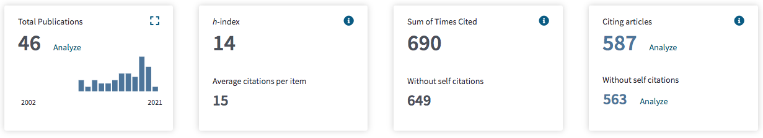

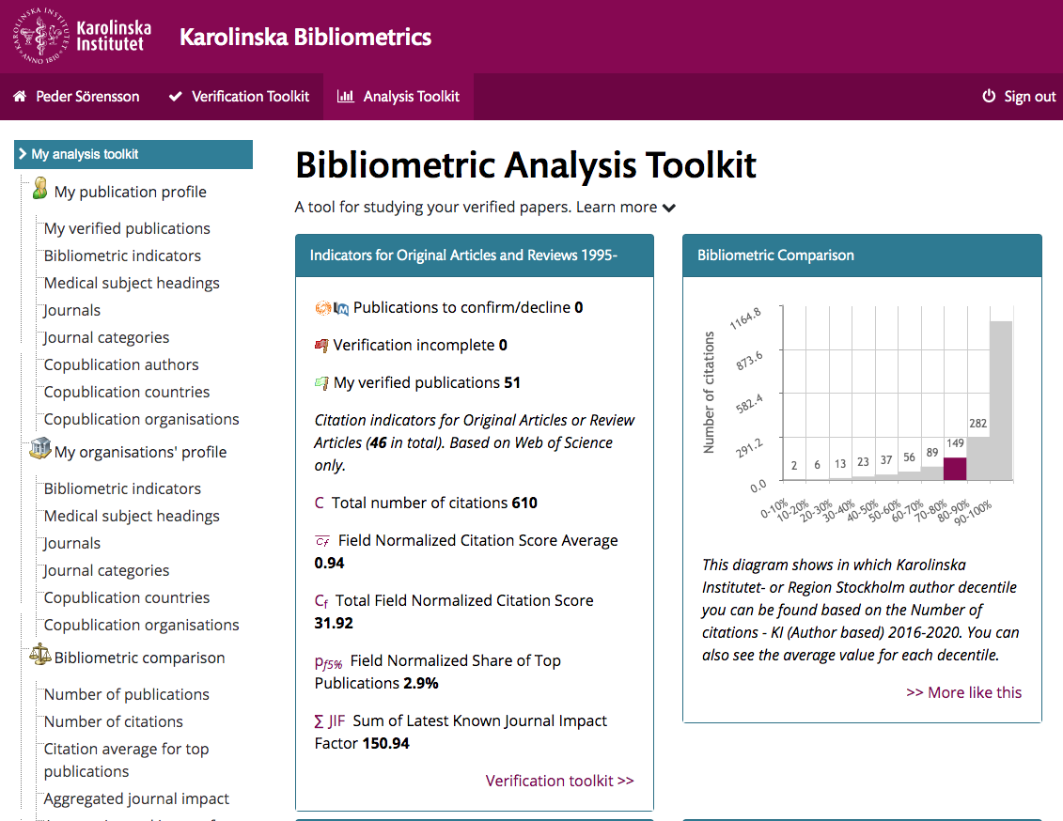

**2.2 List of all original works**

Peer-reviewed papers in scientific journals

1. Rinnström D, Dellborg M, Thilén U, Sörensson P, Nielsen NE, Christersson C, Johansson B. High prevalence of ascending aortic dilation in adults with repaired coarctation of the aorta. Cardiol young. 2021 Feb:1-6.

[View in Medline](http://www.ncbi.nlm.nih.gov/pubmed/33597051?otool=karolib&tool=karolinska)

2. Sandström A, Rinnström D, Kesek M, Thilén U, Dellborg M, Sörensson P, Nielsen NE, Christersson C, Johansson B. Implantable cardiac devices in adult patients with repaired tetralogy of Fallot. Scand Cardiovascular J. 2021 Feb;55(1):22-28.

[View in Medline](http://www.ncbi.nlm.nih.gov/pubmed/32672076?otool=karolib&tool=karolinska)

3. Verouhis D, Sörensson P, Gourine A, Henareh L, Persson J, Saleh N, Settergren M, Sundqvist M, Tengbom J, Tornvall P, Witt N, Böhm F, Pernow J. Long-term effect of remote ischemic conditioning on infarct size and clinical outcomes in patients with anterior ST-elevation myocardial infarction. Catheter Cardiovasc Interv. 2021 Feb 15;97(3):386-392.

[View in Medline](http://www.ncbi.nlm.nih.gov/pubmed/32034857?otool=karolib&tool=karolinska)

4. Ramos JG, Fyrdahl A, Wieslander B, Reiter G, Reiter U, Jin N, Maret E, Eriksson M, Caidahl K, Sörensson P, Sigfridsson A, Ugander M. Cardiovascular magnetic resonance 4D flow analysis has a higher diagnostic yield than Doppler echocardiography for detecting increased pulmonary artery pressure. BMC Med Imaging 2020 Mar 6;20(1):28.

[View in Medline](http://www.ncbi.nlm.nih.gov/pubmed/32143594?otool=karolib&tool=karolinska)

5. Ramos JG, Fyrdahl A, Wieslander B, Thalén S, Reiter G, Reiter U, Jin N, Maret E, Eriksson M, Caidahl K, Sörensson P, Sigfridsson A, Ugander M. Comprehensive Cardiovascular Magnetic Resonance Diastolic Dysfunction Grading Shows Very Good Agreement Compared With Echocardiography. JACC Cardiovasc Imaging. 2020 Dec;13(12):2530-2542.

[View in Medline](http://www.ncbi.nlm.nih.gov/pubmed/32828779?otool=karolib&tool=karolinska)

6. Lundin M, Sörensson P, Maret E, Jenner J, Abdula G, Nickander J, Themudo R, Caidahl K, Kellman P, Sigfridsson A, Ugander M. Diffusely Increased Myocardial Extracellular Volume With or Without Focal Late Gadolinium Enhancement: Prevalence and Associations With Left Ventricular Size and Function. J Thorac Imaging. 2020 Apr 7.

[View in Medline](http://www.ncbi.nlm.nih.gov/pubmed/32271280?otool=karolib&tool=karolinska)

7. Skoglund K, Heimdahl J, Mandalenakis Z, Thilén U, Johansson B, Christersson C, Sörensson P, Dellborg M. Effect of medical treatment in patients with systemic right ventricle. Scand Cardiovasc J. 2020 Oct;54(5):300-305.

[View in Medline](http://www.ncbi.nlm.nih.gov/pubmed/32274953?otool=karolib&tool=karolinska)

8. Nickander J, Lundin M, Abdula G, Jenner J, Maret E, Sörensson P, Heiberg E, Sigfridsson A, Ugander M. Stationary tissue background correction increases the precision of clinical evaluation of intra-cardiac shunts by cardiovascular magnetic resonance. Sci Rep. 2020 Mar;10(1):5053.

[View in Medline](http://www.ncbi.nlm.nih.gov/pubmed/32193468?otool=karolib&tool=karolinska)

9. Verouhis D, Ekström M, Settergren M, Sörensson P, Pernow J, Saleh N. Ticagrelor Does Not Protect Against Endothelial Ischemia-Reperfusion Injury in Patients With Coronary Artery Disease. J Cardiovasc Pharmacol Ther. 2020 Oct 23:1074248420968693.

[View in Medline](http://www.ncbi.nlm.nih.gov/pubmed/33094636?otool=karolib&tool=karolinska)

10. Eldhagen P, Berg S, Lund LH, Sörensson P, Suhr OB, Westermark P. Transthyretin amyloid deposits in lumbar spinal stenosis and assessment of signs of systemic amyloidosis. J Intern Med. 2020 Dec 4.

[View in Medline](http://www.ncbi.nlm.nih.gov/pubmed/33274477?otool=karolib&tool=karolinska)

**# §** 11. Holt CB, Østergaard JA, Thiel S, Hansen TK, Mellbin L, Sörensson P, Bjerre M. Circulating lectin pathway proteins do not predict short-term cardiac outcomes after myocardial infarction. Clin Exp Immunol. 2019 Oct;198(1):94-100.

[View in Medline](http://www.ncbi.nlm.nih.gov/pubmed/31104331?otool=karolib&tool=karolinska)

**#** 12. Beitner N, Jenner J, Sörensson P. Comparison of Left Ventricular Volumes Measured by 3DE, SPECT and CMR. J Cardiovasc Imaging. 2019 Jul;27(3):200-211.

[View in Medline](http://www.ncbi.nlm.nih.gov/pubmed/31161750?otool=karolib&tool=karolinska)

13. Jenner J, Sörensson P, Pernow J, Caidahl K, Eriksson MJ. Contrast Enhancement and Image Quality Influence Two- and Three-dimensional Echocardiographic Determination of Left Ventricular Volumes: Comparison With Magnetic Resonance Imaging. Clin Med Insights Cardiol. 2019 Mar 5;13:1179546819831980.

[View in Medline](http://www.ncbi.nlm.nih.gov/pubmed/30858745?otool=karolib&tool=karolinska)

14. Lundin M, Sörensson P, Vishnevskaya L, Maret E, Kellman P, Sigfridsson A, Ugander M. Detection of myocarditis using T1 and ECV mapping is not improved by early compared to late post-contrast imaging. Clin Physiol Funct Imaging. 2019 Nov;39(6):384-392.

[View in Medline](http://www.ncbi.nlm.nih.gov/pubmed/31132211?otool=karolib&tool=karolinska)

**#** 15. Darlington P, Gabrielsen A, Cederlund K, Kullberg S, Grunewald J, Eklund A, Sorensson P. Diagnostic approach for cardiac involvement in sarcoidosis. Sarcoidosis Vasc Diffuse Lung Dis. 2019;36(1):11-17.

[View in Medline](http://www.ncbi.nlm.nih.gov/pubmed/32476931?otool=karolib&tool=karolinska)

16. Sandtröm A, Sandberg C, Rinnström D, Engström G, Dellborg M, Thilén U, Sörensson P, Nielsen NE, Christersson C, Johansson B. Factors associated with health-related quality of life among adults with tetralogy of Fallot. Open heart. 2019 Feb 27;6(1):e000932.

[View in Medline](http://www.ncbi.nlm.nih.gov/pubmed/30997127?otool=karolib&tool=karolinska)

17. Hjort M, Eggers KM, Lindhagen L, Agewall S, Brolin EB, Collste O, Daniel M, Ekenbäck C, Frick M, Henareh L, Hofman-Bang C, Malmqvist K, Spaak J, Sörensson P, Y-Hassan S, Tornvall P, Lindahl B. Increased Inflammatory Activity in Patients 3 Months after Myocardial Infarction with Nonobstructive Coronary Arteries. Clin Chem. 2019 Aug;65(8):1023-1030.

[View in Medline](http://www.ncbi.nlm.nih.gov/pubmed/31072836?otool=karolib&tool=karolinska)

18. Nero D, Agewall S, Daniel M, Caidahl K, Collste O, Ekenbäck C, Frick M, Henareh L, Jernberg T, Malmqvist K, Schenck-Gustafsson K, Spaak J, Sörensson P, Sundin Ö, Y-Hassan S, Hofman-Bang C, Tornvall P. Personality Traits in Patients with Myocardial Infarction with Nonobstructive Coronary Arteries. Am J Med. 2019 Mar;132(3):374-381.e1.

[View in Medline](http://www.ncbi.nlm.nih.gov/pubmed/30503881?otool=karolib&tool=karolinska)

19. Verouhis D, Saleh N, Settergren M, Sörensson P, Gourine A, Pernow J. Remote ischemic conditioning protects against endothelial ischemia-reperfusion injury via a glucagon-like peptide-1 receptor-mediated mechanism in humans. Int J Cardiol. 2019 Jan 1;274:40-44.

[View in Medline](http://www.ncbi.nlm.nih.gov/pubmed/30268384?otool=karolib&tool=karolinska)

20. Thalen S, Maanja M, Sigfridsson A, Maret E, Sorensson P, Ugander M. The dynamics of extracellular gadolinium-based contrast agent excretion into pleural and pericardial effusions quantified by T1 mapping cardiovascular magnetic resonance. J Cardivasc Magn Reson. 2019 Nov 14;21(1):71.

[View in Medline](http://www.ncbi.nlm.nih.gov/pubmed/31730498?otool=karolib&tool=karolinska)

21. Axelsson J, Wieslander B, Jablonowski R, Klem I, Nijveldt R, Schelbert EB, Sörensson P, Sigfridsson A, Chaudhry U, Platonov PG, Borgquist R, Engblom H, Strauss DG, Arheden H, Atwater BD, Ugander M. Ejection fraction in left bundle branch block is disproportionately reduced in relation to amount of myocardial scar. J Electrocardiol. 2018 Nov-Dec;51(6):1071-1076.

[View in Medline](http://www.ncbi.nlm.nih.gov/pubmed/30497733?otool=karolib&tool=karolinska)

22. Daniel M, Agewall S, Berglund F, Caidahl K, Collste O, Ekenbäck C, Frick M, Henareh L, Jernberg T, Malmqvist K, Schenck-Gustafsson K, Spaak J, Sundin Ö, Sörensson P, Y-Hassan S, Hofman-Bang C, Tornvall P. Prevalence of Anxiety and Depression Symptoms in Patients with Myocardial Infarction with Non-Obstructive Coronary Arteries. Am J Med. 2018 Sep;131(9):1118-1124.

[View in Medline](http://www.ncbi.nlm.nih.gov/pubmed/29859805?otool=karolib&tool=karolinska)

23. Abdula G, Nickander J, Sörensson P, Lundin M, Kellman P, Sigfridsson A, Ugander M. Synthetic late gadolinium enhancement cardiac magnetic resonance for diagnosing myocardial scar. Scand Cardiovasc J. 2018 Jun;52(3):127-132.

[View in Medline](http://www.ncbi.nlm.nih.gov/pubmed/29544374?otool=karolib&tool=karolinska)

24. Wieslander B, Xia X, Jablonowski R, Axelsson J, Klem I, Nijveldt R, Maynard C, Schelbert EB, Sörensson P, Sigfridsson A, Chaudhry U, Platonov PG, Borgquist R, Engblom H, Couderc JP, Strauss DG, Atwater BD, Ugander M. The ability of the electrocardiogram in left bundle branch block to detect myocardial scar determined by cardiovascular magnetic resonance.

J Electrocardiol. 2018 Sep-Oct;51(5):779-786.

[View in Medline](http://www.ncbi.nlm.nih.gov/pubmed/30177312?otool=karolib&tool=karolinska)

25. Nickander J, Lundin M, Abdula G, Sörensson P, Rosmini S, Moon JC, Kellman P, Sigfridsson A, Ugander M. Blood correction reduces variability and gender differences in native myocardial T1 values at 1.5 T cardiovascular magnetic resonance - a derivation/validation approach. J Cardiovasc Magn Reson. 2017 Apr 5;19(1):41.

[View in Medline](http://www.ncbi.nlm.nih.gov/pubmed/28376820?otool=karolib&tool=karolinska)

26. Daniel M, Agewall S, Caidahl K, Collste O, Ekenbäck C, Frick M, Y-Hassan S, Henareh L, Jernberg T, Malmqvist K, Schenck-Gustafsson K, Sörensson P, Sundin Ö, Hofman-Bang C, Tornvall P. Effect of Myocardial Infarction With Nonobstructive Coronary Arteries on Physical Capacity and Quality-of-Life. Am J Cardiol. 2017 Aug 1;120(3):341-346.

[View in Medline](http://www.ncbi.nlm.nih.gov/pubmed/28610801?otool=karolib&tool=karolinska)

27. Rinnström D, Dellborg M, Thilén U, Sörensson P, Nielsen NE, Christersson C, Ugander M, Johansson B. Poor blood pressure control in adults with repaired coarctation of the aorta and hypertension: a register-based study of associated factors. Cardiol Young. 2017 Nov;27(9 ):1708-1715.

[View in Medline](http://www.ncbi.nlm.nih.gov/pubmed/28703088?otool=karolib&tool=karolinska)

28. De Palma R, Sörensson P, Verouhis D, Pernow J, Saleh N. Quantification of myocardium at risk in ST- elevation myocardial infarction: a comparison of contrast-enhanced steady-state free precession cine cardiovascular magnetic resonance with coronary angiographic jeopardy scores. J Cardiovasc Magn Reson. 2017 Jul 27;19(1):55.

[View in Medline](http://www.ncbi.nlm.nih.gov/pubmed/28750637?otool=karolib&tool=karolinska)

29. Tornvall P, Brolin EB, Caidahl K, Cederlund K, Collste O, Daniel M, Ekenbäck C, Jensen J, Y-Hassan S, Henareh L, Hofman-Bang C, Lyngå P, Maret E, Sarkar N, Spaak J, Sundqvist M, Sörensson P, Ugander M, Agewall S. The value of a new cardiac magnetic resonance imaging protocol in Myocardial Infarction with Non-obstructive Coronary Arteries (MINOCA) - a case-control study using historical controls from a previous study with similar inclusion criteria. BMC Cardiovasc Disord. 2017 Jul 24;17(1):199.

[View in Medline](http://www.ncbi.nlm.nih.gov/pubmed/28738781?otool=karolib&tool=karolinska)

30. Tufvesson J, Carlsson M, Aletras AH, Engblom H, Deux JF, Koul S, Sörensson P, Pernow J, Atar D, Erlinge D, Arheden H, Heiberg E. Automatic segmentation of myocardium at risk from contrast enhanced SSFP CMR: validation against expert readers and SPECT. BMC Med Imaging. 2016 Mar 5;16: 19.

[View in Medline](http://www.ncbi.nlm.nih.gov/pubmed/26946139?otool=karolib&tool=karolinska)

31. Verouhis D, Sörensson P, Gourine A, Henareh L, Persson J, Saleh N, Settergren M, Sundqvist M, Tornvall P, Witt N, Böhm F, Pernow J. Effect of remote ischemic conditioning on infarct size in patients with anterior ST-elevation myocardial infarction. Am Heart J. 2016 Nov;181:66-73.

[View in Medline](http://www.ncbi.nlm.nih.gov/pubmed/27823695?otool=karolib&tool=karolinska)

32. Berglund E, Johansson B, Dellborg M, Sörensson P, Christersson C, Nielsen NE, Rinnström D, Thilén U. High incidence of infective endocarditis in adults with congenital ventricular septal defect. Heart. 2016 Nov 15;102(22): 1835-1839.

[View in Medline](http://www.ncbi.nlm.nih.gov/pubmed/27443390?otool=karolib&tool=karolinska)

33. Rinnström D, Dellborg M, Thilén U, Sörensson P, Nielsen NE, Christersson C, Johansson B. Hypertension in adults with repaired coarctation of the aorta. Am Heart J. 2016 Nov;181:10-15.

[View in Medline](http://www.ncbi.nlm.nih.gov/pubmed/27823680?otool=karolib&tool=karolinska)

34. Rinnström D, Dellborg M, Thilén U, Sörensson P, Nielsen NE, Christersson C, Johansson B. Left ventricular hypertrophy in adults with previous repair of coarctation of the aorta; association with systolic blood pressure in the high normal range. Int J Cardiol. 2016 Sep 1;218:59-64.

[View in Medline](http://www.ncbi.nlm.nih.gov/pubmed/27232912?otool=karolib&tool=karolinska)

35. Sandberg C, Rinnström D, Dellborg M, Thilén U, Sörensson P, Nielsen NE, Christersson C, Wadell K, Johansson B. Height, weight and body mass index in adults with congenital heart disease. Int J Cardiol. 2015 187:219-26.

[View in Medline](http://www.ncbi.nlm.nih.gov/pubmed/25838217?otool=karolib&tool=karolinska)

36. Tornvall P, Gerbaud E, Behaghel A, Chopard R, Collste O, Laraudogoitia E, Leurent G, Meneveau N, Montaudon M, Perez-David E, Sörensson P, Agewall S. Myocarditis or "true" infarction by cardiac magnetic resonance in patients with a clinical diagnosis of myocardial infarction without obstructive coronary disease: A meta-analysis of individual patient data. Atherosclerosis. 2015 Jul;241(1):87-91.

[View in Medline](http://www.ncbi.nlm.nih.gov/pubmed/25967935?otool=karolib&tool=karolinska)

37. Daniel M, Ekenbäck C, Agewall S, Brolin EB, Caidahl K, Cederlund K, Collste O, Eurenius L, Frick M, Younis-Hassan S, Henareh L, Jernberg T, Malmqvist K, Spaak J, Sörensson P, Hofman-Bang C, Tornvall P. Risk Factors and Markers for Acute Myocardial Infarction With Angiographically Normal Coronary Arteries. Am J Cardiol. 2015 Sep;116(6):838-44.

[View in Medline](http://www.ncbi.nlm.nih.gov/pubmed/26251000?otool=karolib&tool=karolinska)

38. Darlington P, Gabrielsen A, Sörensson P, Cederlund K, Eklund A, Grunewald J. Cardiac involvement in Caucasian patients with pulmonary sarcoidosis. Respir Res. 2014 Feb 7;15:15.

[View in Medline](http://www.ncbi.nlm.nih.gov/pubmed/24506975?otool=karolib&tool=karolinska)

39. Darlington P, Gabrielsen A, Sörensson P, Tallstedt L, Padyukov L, Eklund A, Grunewald J. HLA-alleles associated with increased risk for extra-pulmonary involvement in sarcoidosis. Tissue antigens. 2014 Apr;83(4):267-72.

[View in Medline](http://www.ncbi.nlm.nih.gov/pubmed/24641503?otool=karolib&tool=karolinska)

40. Sörensson P, Rydén L, Saleh N, Tornvall P, Arheden H, Pernow J. Long-term impact of postconditioning on infarct size and left ventricular ejection fraction in patients with ST-elevation myocardial infarction. BMC Cardiovasc Disord. 2013 Mar 25;13:22.

[View in Medline](http://www.ncbi.nlm.nih.gov/pubmed/23530474?otool=karolib&tool=karolinska)

**§** 41. Collste O, Sörensson P, Frick M, Agewall S, Daniel M, Henareh L, Ekenbäck C, Eurenius L, Guiron C, Jernberg T, Hofman-Bang C, Malmqvist K, Nagy E, Arheden H, Tornvall P. Myocardial infarction with normal coronary arteries is common and associated with normal findings on cardiovascular magnetic resonance imaging: results from the Stockholm Myocardial Infarction with Normal Coronaries study. J Intern Med. 2013 Feb;273(2):189-96.

[View in Medline](http://www.ncbi.nlm.nih.gov/pubmed/22742529?otool=karolib&tool=karolinska)

42. Jung C, Sorensson P, Saleh N, Arheden H, Ryden L, Pernow J. Circulating endothelial and platelet derived microparticles reflect the size of myocardium at risk in patients with ST-elevation myocardial infarction. Atherosclerosis. 2012 Mar;221(1):226-31.

[View in Medline](http://www.ncbi.nlm.nih.gov/pubmed/22245039?otool=karolib&tool=karolinska)

43. Ubachs JF, Sörensson P, Engblom H, Carlsson M, Jovinge S, Pernow J, Arheden H. Myocardium at risk by magnetic resonance imaging: head-to-head comparison of T2-weighted imaging and contrast-enhanced steady-state free precession. Eur Heart J Cardiovasc Imaging. 2012 Dec;13(12):1008-15.

[View in Medline](http://www.ncbi.nlm.nih.gov/pubmed/22645203?otool=karolib&tool=karolinska)

44. Soneson H, Engblom H, Hedstrom E, Bouvier F, Sorensson P, Pernow J, Arheden H, Heiberg E. An automatic method for quantification of myocardium at risk from myocardial perfusion SPECT in patients with acute coronary occlusion. J Nucl Cardiol. 2010 Oct;17(5):831-40.

[View in Medline](http://www.ncbi.nlm.nih.gov/pubmed/20440591?otool=karolib&tool=karolinska)

45. Sorensson P, Heiberg E, Saleh N, Bouvier F, Caidahl K, Tornvall P, Ryden L, Pernow J, Arheden H. Assessment of myocardium at risk with contrast enhanced steady-state free precession cine cardiovascular magnetic resonance compared to single-photon emission computed tomography. J Cardiovasc Magn Reson. 2010 Apr 30;12:25.

[View in Medline](http://www.ncbi.nlm.nih.gov/pubmed/20433716?otool=karolib&tool=karolinska)

46. Sorensson P, Saleh N, Bouvier F, Bohm F, Settergren M, Caidahl K, Tornvall P, Arheden H, Ryden L, Pernow J. Effect of postconditioning on infarct size in patients with ST elevation myocardial infarction. Heart. 2010 Nov;96(21): 1710-5.

[View in Medline](http://www.ncbi.nlm.nih.gov/pubmed/20956486?otool=karolib&tool=karolinska)

Disclaimer

Certain data included herein are derived from the Web of Science prepared by Clarivate Analytics, Inc. (Clarivate), Philadelphia, Pennsylvania, USA: Copyright Clarivate Analytics Group 2021. All rights reserved.

Data specified as deriving from MEDLINE/PubMed was updated 2021-02-23. NLM represents that its data were formulated with a reasonable standard of care. Except for this representation, NLM makes no representation or warranties, expressed or implied. This includes, but is not limited to, any implied warranty of merchantability or fitness for a particular purpose, with respect to the NLM data, and NLM specifically disclaims any such warranties and representations. All complete or parts of U.S. National Library of Medicine (NLM) records that are redistributed or retransmitted must be identified as being derived from NLM data.

**2.3 The ten most-cited publications**

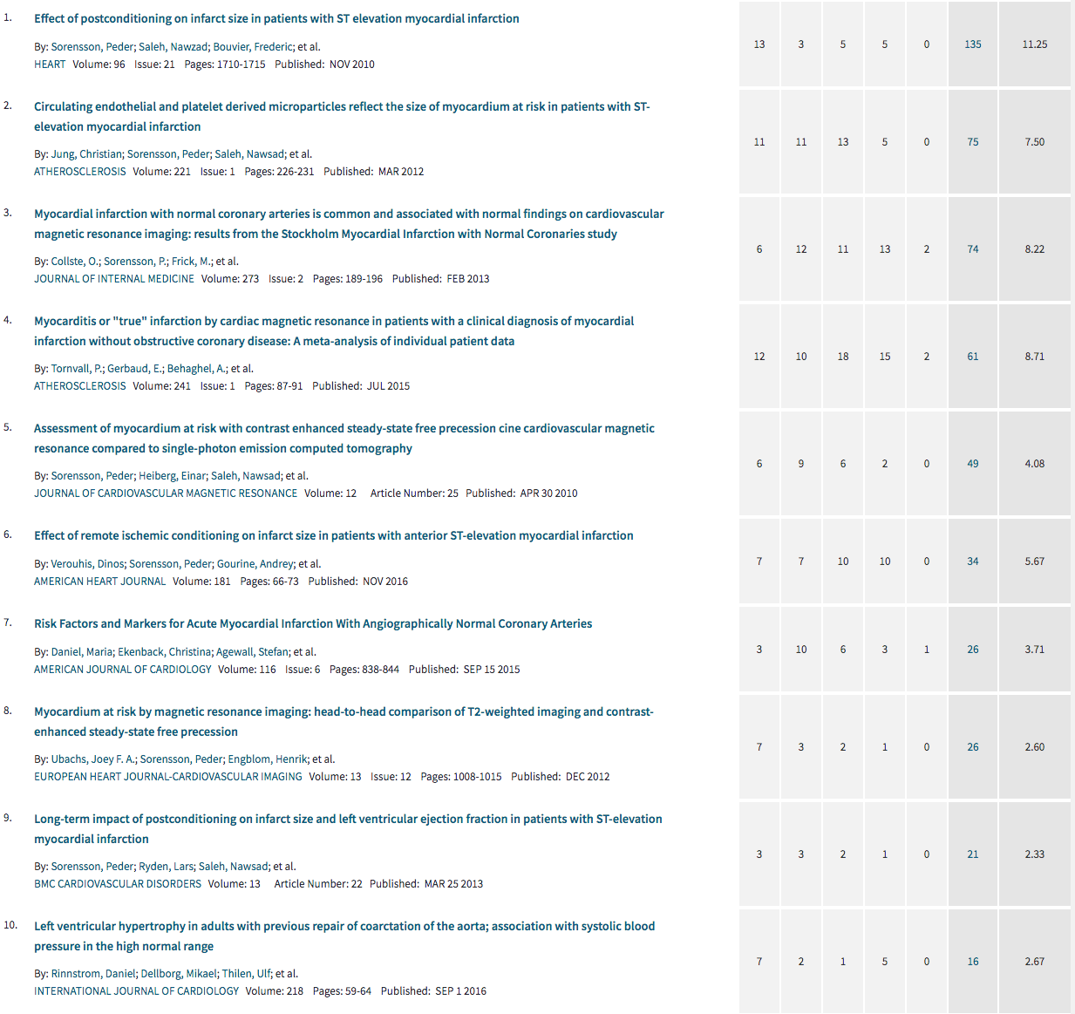

**2.4 The ten most important publications**

First nine articles above and:

**Sörensson P**, Ekenbäck C, Lundin M, Agewall S, Bacsovics Brolin E, Caidahl K, Cederlund K, Collste O, Daniel M, Jensen J, Y-Hassan S, Henareh L, Hofman-Bang C, Lyngå P, Maret E, Sarkar N, Spaak J, Winnberg O, Ugander M, Tornvall P. Early comprehensive cardiac magnetic resonance imaging in patients with myocardial infarction with non-obstructive coronary arteries, JACC Cardiovascular imaging, 2021-02-19, **accepted**, see attached file in application.

**2.5 List of general articles and book chapters**

Athletes’ and the heart, CMR imaging, Studentlitteratur, M Börjesson & M Dellborg, 2016.

Co-writer of National guidelines for diagnosing and treatment of sarcoidosis and cardiac sarcoidosis. 2014 and 2018.

**2.6 List of all other scientific works**

Co-investigator, bed rest study, Toulouse, European Space Association (ESA), 2002

QUICC- QUality Improvement in acute coronary care in Sweden, co-investigator at the Dep. of Cardiology, Solna. Co-investigator together with Dr Claes Held, 2004.

Starting the *Fetal-CMR* imaging group of Karolinska in 2020, first three patients included as a method development study. Joint venture with children’s radiology and cardiology departments. Also co-operation together with Lund CMR group. Ethical approvement 200325, Dnr 2019-05923.

Co-founder of the scientific cooperation between Stockholm and Gothenburg cardiomyopathy groups, science interest cardiac sarcoidosis, database and two manuscripts in progress, 2020-

**3 INTERNATIONAL SCIENTIFIC CONGRESSES**

**3.1 Invited speaker or chair**

**3.2 Oral presentations of own accepted abstracts**

Oral abstract presentation, “Early CMR including T1 and ECV mapping increases diagnostic yield in myocardial infarction with normal coronary arteries”**,** Society of Cardiovascular Magnetic Resonance, SCMR 23RD, Orlando, FL, 2020.

Oral abstract presentation, “Long-term impact of postconditioning on infarct size and left ventricular ejection fraction in patients with ST-elevation myocardial infarction”, European Society of Cardiology (ESC), Paris. 2011.

Oral abstract presentation, “Effect of postconditioning on infarct size in patients with ST elevation myocardial infarction” American Heart Association, Orlando, FL, 2009.

**4 RESEARCH FUNDING OBTAINED IN THE PAST FIVE YEARS**

**4.1 External research funding obtained in international or national competition as *principal applicant***

Ingrid Olaussons vascular foundation, 225 000 Skr, 2016-2017.

**4.2 External research funding obtained in international or national competition as *co-applicant***

RECOND-study, “Effect of remote ischemic conditioning on infarct size in patients with anterior ST-elevation myocardial infarction” three months of research salary times three years, Heart and Lung foundation, 2016-2018.

**4.3 Significant other research funding received (donation, grant in local competition – e.g. ALF project) as *principal applicant***

-

**4.4 Significant other research funding received (donation, grant in local competition – e.g. ALF project) as *co-applicant***

27.7 million Skr, donation from Familjen Erling-Perssons Stiftelse to the Institution of Medicine, Solna, KI, 2012.

Familjen Erling-Perssons Stiftelse, 12 739 000 Skr, Heart and vascular MRI research, 2018. Continuing funding from the basic research donation in 2012.

1 029 000 Skr, Remote ischemic conditioning: a new method for decreasing infarct size in patients with acute myocardial infarction, ALF, 2015-2016.

634 000 Skr, Cardiac Imaging During Free Breathing with Magnetic Resonance Imaging, ALF, 2016.

723 000 Skr, DIRECT TAVI – a randomized study of direct implantation of percutaneous aorta valve prothesis, ALF, 2016.

Heart and Lung foundation, PhD grants 450 000 Skr/year, 2010-2012

Heart and Lung foundation, PhD grants 60 000 Skr/year, 2008-2010.

Odd Fellow Research Fond: 250 000 Skr, 2010.

**5 SCIENTIFIC COLLABORATIONS**

Professor John Pernow, Department of Cardiology, Institution of medicine, Solna, KI, Cardiovascular reperfusion-injury studies.

Professor Per Tornvall, KI Södersjukhuset, Stockholm myocardial infarction with normal coronary arteries (SMINC-1, SMINC-2).

Senior professor Lars Ryden, Institution of Medicine, Solna, KI, Stress-perfusion MRI in patients with diabetes mellitus.

Professor Peter Kellman, NIH (National Institute of Health), USA, T1-mapping, extracellular volume (ECV) and perfusion-MRI.

Professor Martin Ugander, Kolling Institute, Royal North Shore Hospital, and Charles Perkins Centre, Faculty of Medicine and Health, University of Sydney, Sydney, Australia. CMR studies.

Professor Håkan Arheden, Department of clinical physiology, Lund University Hospital, CMR and myocardial infarction.

Professor Anders Eklund and Johan Grünewald, Department of pulmonary diseases, Karolinska University Hospital, Cardiac sarcoidosis.

Professor Mats Börjesson, Sahlgrenska University Hospital, Gothenburg, Athletes and cardiac disease.

Associate professor Entela Bollano and Associate professor Niklas Bergh, Institution of medicine, University of Gothenburg, Sahlgrenska Cardiomyopathy Centre, Sahlgrenska Academy. Cardiac sarcoidosis.

Professor Henrik Engblom, Institution of MMK, KI. Cardiovascular MRI.

Professor Mikael Dellborg and Associate professorZacharias Mandalenakis, Sahlgrenska University Hospital, Gothenburg, ACHD.

Professor Bengt Johansson, Heart Centre and Department of Public Health and Clinical Medicine, Umeå University, ACHD.

Associate professor Linda Mellbin, Karolinska Institutet, Department of Medicine, Solna, Myocardial infarction and patients with diabetes.

**6 SUPERVISION OF GRADUATE STUDENTS**

**6.1 PhD candidates supervised up to the defence of the candidate’s doctoral thesis, with the applicant serving as *main supervisor***

-

**6.2 PhD candidates supervised up to the defence of the candidate’s doctoral thesis, with the applicant serving as *co-supervisor***

Dinos Verouhis, Institution of Medicine, Solna, KI. Dissertation, 20190524.

Jannike Nickander, Institution of MMK, Stockholm, KI. Dissertation 20180413.

**6.3 Students supervised up to their licentiate degree, with the applicant serving as *main supervisor***

-

**6.4 Students supervised up to their licentiate degree, with the applicant serving as *co-supervisor***

Rebecca Steffen Johansson, Study Program in Medicine, Institution of MMK, KI, 2019.

**6.5 Ongoing supervision of a PhD candidate, with the applicant serving as *main supervisor***

Per Eldhagen, Institution of Medicine, Solna, KI. Registration 20200304.

**6.6 Ongoing supervision of a PhD candidate, with the applicant serving as *co-supervisor***

Goran Abdula, Institution of MMK, KI. Registration 20131126.

Simon Thalen, Institution of MMK, KI. Registration 20160701.

Oscar Winnberg, Institution of Clinical Science and Education, Södersjukhuset. Registration 20190329.

**6.7 Postdoc supervision**

-

**6.8 Supervision of other researchers who have defended a thesis**

-

**6.9 Ongoing careers of holders of earlier PhDs and of postdocs**

-

**7 THESIS EVALUATION**

**7.1 Serving as thesis opponent**

Opponent for Runa Hyldgaard Poulsen, PhD-student, “Imaging Myocardium at risk after ischemia and reperfusion. Myocardial distribution of 99mTc and 99mTC-lactadherin in an experimental pig model” Faculty of Health, Aarhus University, Denmark. 2012.

**7.2 Serving as a member of a thesis examination committee**

-

**7.3 External thesis reviewer**

-

8 EVALUATION OF OTHERS’ WORK

**8.1 Serving as reviewer of candidates proposed for academic positions**

-

**8.2 Serving as reviewer for international evaluations**

-

**8.3 Evaluator of research applications in international competition**

-

**8.4 Evaluator of research applications in national competition**

-

**8.5 Evaluator of major research grant applications in local competition**

-

**8.6 Editor of scientific journals**

-

**8.8 Member of an editorial board**

-

**8.8 Referee for scientific journals**

Circ Cardiovasc Interv, Remote Ischemic Postconditioning During Percutaneous Coronary Interventions - CIRCULATIONAHA/2013/005747RIP-PCI-trial, 2013.

Basic Res Cardiol, 20130319-03 "Impact of Multiple Balloon Inflations during Primary Percutaneous Coronary Intervention on Infarct Size and Long-Term Clinical Outcomes in ST-Segment Elevation Myocardial Infarction: Real-World Postconditioning ", 2014.

European Heart Journal Cardiovascular Imaging, EHJCI-D-19-01364  
Non-invasive characterization of pleural and pericardial effusions using T1 Mapping by Magnetic Resonance Imaging, 2019.

International Journal of Cardiovascular Imaging, CAIM-D-20-00668, Prognostic Significance of Cardiac Magnetic Resonance-Based Markers in Patients with Hypertrophic Cardiomyopathy, 2020.

PLOS ONE, PONE-D-20-22483, Comparison of the within-reader and inter-vendor agreement of left ventricular circumferential strains and volume indices derived from cardiovascular magnetic resonance imaging, 2020

Translational Sports Medicine, TSM-Jul-2020-0128 entitled "The “abnormal” echocardiogram in elite football players: a proposition for new reference values." 2020.

Läkartidningen, LT-20-120.R1, Bröstsmärta vid COVID-19: En hjärtefråga, 2020.

**8.8 Reviewer or advisor for other scientific bodies**

-

**8.9 Other relevant evaluation assignments**

-

**9 INTERNATIONAL VISITING RESEARCH FELLOWSHIPS**

-

**10 SCIENTIFIC DISTINCTIONS**

-

**11 OTHER SCIENTIFIC MERITS**

-

**12 RESEARCH PLAN**

See attached research application.

**KAROLINSKA INSTITUTET**

TEACHING PORTFOLIO

**1 SUBJECT AREA COMPETENCE AND CURRENT TEACHING**

**ACTIVITY**

See separate education table.

2 TEACHING IN THE STUDY PROGRAMME

Teaching medical students, nurses and specialist training doctors each semester in seminars, bed-side, lectures and cardiovascular imaging. 2006-

Lectures for doctors in specialist training in internal medicine, cardiology and children cardiology. 2012-

Head of teaching for medical students at the department of cardiology, 2006-2007, awarded best clinical teaching price.

**2.1 Scope/time of teaching**

10 hours/semester since 2006, more than 200 hours from 2006-

**2.2 Form of instruction**

-

**2.3 Teaching assignments**

Medical students (cardiovascular imaging), twice per semester (lectures, bedside and seminars), clinical amanuensis (2006-2007), 2006-

Cardiology specialist education (SK-course), MRI and Cardiomyopathy, Danderyd Hospital, 2010-2013.

Responsible for Specialist course in Adult congenital Heart disease, Karolinska University Hospital, 2019.

Responsible for teaching MRI to clinical Physiologists’ under training, two persons per semester since 2013-

**2.4 Examination and assessment**

Clinical examination for medical students, 2004 – 2008.

Bed-side examination for medical students, 2006 – 2008.

**2.5 Production of study materials and instructional materials**

PM for cardiac MRI concerning pregnancy and breastfeeding.

PM for cardiac MRI concerning contrast agent allergic reactions.

PM for cardiac MRI concerning kidney insufficiency.

PM for cardiac MRI concerning pacemaker, ICD and CRT-P/D.

PM for cardiac MRI concerning clinical protocols.

PM for cardiac MRI concerning Adenosin and stress perfusion.

PM for cardiac MRI concerning Anaesthesiology and sleeping patients.

PM for cardiac MRI concerning Cardiac arrest.

All above PM’s is up-dated every other year.

**2.6 Course evaluation, and evaluation of instruction and study programme**

Course evaluation for medical students is performed after each semester and feed-back is sent to all teachers who have lectures and seminars.

Structured evaluation of specialists after cardiology and physiology training at the cardiac MRI scanner, only persons who attend more than 8 weeks.

**2.7 Internationalisation**

Annually several Erasmus students attending Karolinska University Hospital and the Cardiology Unit, they participate in all education program, lectures and seminars.

In 2018, a Belarus fellow visited for two weeks training clinical CMR and CMR research.

3 TEACHING IN NURSING AND MEDICINE AND FOR HEALTHCARE PRACTITIONERS

**3.1 Teaching in nursing and medicine**

Annually, lectures for nurses and physiotherapists in cardiovascular imaging, ACHD and sports cardiology, 2013-

**3.2 Teaching for healthcare practitioners**

See above.

4 DEVELOPMENT OF TEACHING SKILLS

**4.1 Formal studies in university-level teaching**

Two days course in supervision of clinical doctors at Karolinska University Hospital Huddinge, 2010.

Introductory Doctorial Supervision Course, 10-14 Nov, KI, 2014.

Teaching and Learning in Higher Education, distance course (GHPD), five weeks, Karolinska Institutet, 2019.

Karolinska Clinical School of associate professorship (Docentskolan) Karolinska University Hospital, 2019-2020.

**4.2 Other teaching activities**

See separate education table.

5 DEVELOPMENT WORK IN TEACHING/MEDICAL PEDAGOGY

**5.1 Pedagogical development work and projects**

-

**5.2 Communication and presentations of pedagogical development work**

-

6 TEACHING DISTINCTIONS

-

**7 OTHER TEACHING MERITS**

**-**

8 CONCRETE EXAMPLES AND REFLECTIONS ON YOUR OWN TEACHING

**1. Describe the teaching/supervision opportunity**

My current teaching assignment contains of lecturing twice a year at the internal medicine course for medical students in their 5th semester of medicine school at Karolinska University Hospital, Stockholm. I also tutor at different clinical seminars in specific cardiology topics like advanced cardiac imaging or adult congenital heart disease. The lector I’m going to describe is part of a four week long theoretic education for medical students at Karolinska Institutet before they start their first clinical rotation at different hospitals in the area of Stockholm. The course has both classic cathedral lectures and smaller group seminars. Teaching goals for this course is well described in the study plan both for the different internal medicine specialties and the clinical knowledge which is divided into different levels according to SOLO-taxonomies: S1 – S4 (theory) and clinical skills according to Millers pyramid: M1 – M4. My departments specific learning goals for this rotation is shown below (in Swedish) and my lector involves different methods of cardiac imaging especially cardiovascular magnetic resonance imaging (CMR). The student has earlier in the week learned about general acute internal medicine problems and an introduction in cardiac dysfunctions.

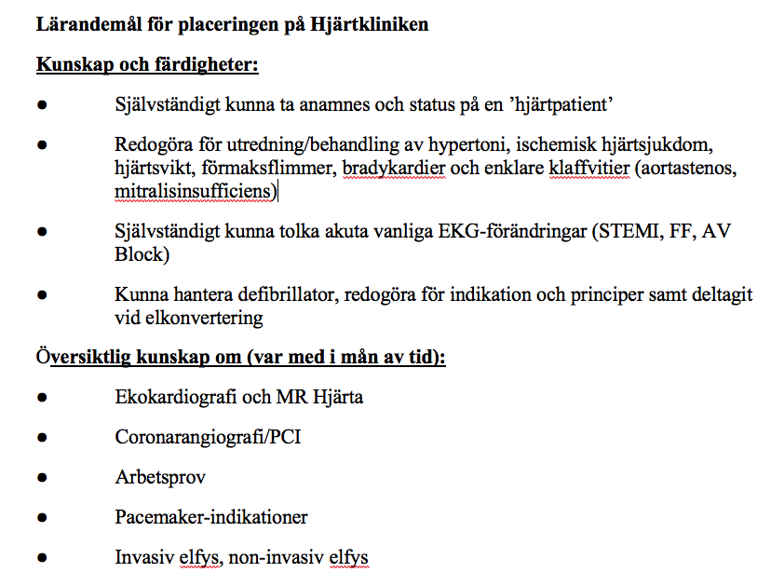

Usually I have one hour at my disposal. The participation of the students varies from 20 – 35 persons depending on the time of the event. All lectors are voluntary. I think that the level of student knowledge is fairly similar from semester to the next semester because they all study the same topic at the same time. My lecture is about different acute and chronic heart disease using CMR as a tool for cardiac diagnosing. I use the computer program Power Point and show a lot of moving loops and pictures in black and white and color. At start I encourage the audience to interrupt me as soon as they want or doesn’t understand what I’m trying to show/explain/teach. Sometimes the first questions asked make me have to go back to more basics understanding in cardiac imaging in order to repeat key factors for understanding the technical issues and the interpretation of images. The main goal is to make them understand the MR-images and how to use them in order to diagnose different heart diseases. Finally, I use to divide the student into smaller group (bee hives) in order to analyze by themselves different real-life cases and to propose a working diagnose and speculate on why they have come up with this suggestion. Usually the time is not long enough for any immediate reflection on the teaching opportunity by myself or the students. Feed-back to the teaching faculty on their lecture contains of a grade-system from 1 – 5 with optional comments at the end of the semester.

**2) Reviewing teaching/supervision opportunity**

When reviewing this teaching opportunity, you immediately think of the two strategies of learning by Elmgren & Henriksson 2010. The first strategy is superficial learning explained by external knowledge where you learn by heart and do not understand the right context or relate knowledge to your own experience. A traditional lecture in a new advanced imaging technic can easily go into this first strategy of learning. The students having problems of understanding and they do not have any experience of their own to relate to this subject which leads into passive learning with low commitment and participation. The second strategy is in-depth learning where you connect the new knowledge to prior experience and knowledge and that the students understand the intention of what is demonstrated. As a teacher you need to “capture/enthuse” the students by describing and explaining facts in an easy fashion so that you increase the involvement and interest of learning more about this new imaging method and opportunity to find the correct diagnose. In my lecture I focus mainly on different pictures of the heart in different colors, angels and shapes. Often, I show spectacular case presentation to tease the student to want to learn more about cardiology or CMR.

Richardson J, 2005, summarizes in his article that the students can be divided into five categories where the first three learning steps constitutes ways to increase knowledge by memorizing facts as more of superficial learning and the two latter steps focus on in-depth learning by processing information yourself, analyze and put it into a new context. If you want to increase the in-depth learning process you also have to motivate the students according to Elmgren and the students that attend your lecture have to be activated with questions and problems to solve. People that attend lectures is known to have higher motivation to start with.

Studies show that if teachers put in elements that stimulates activity during the lesson is perceived as very positive by the students. One such strategy for student centered learning is “Peer Instruction” – Eric Mazur (professor in physics at Harvard) – this technic uses small groups of students who discusses a question from the teacher among themselves for a couple of minutes and tries to answer this by learning from each other and not only by the teacher. This is a technic I used for the first-time last semester. The student got a couple of case reports and CMR pictures to analyze together in small groups for five minutes and then each group had to explain how they were thinking and come up with a suggestion of diagnosis to the larger group. I interpreted that the students appreciated this attempt to further activate their ability to conclude and gather up facts. On the other side this is hard to evaluate and always extremely individual to the specific student. In my point of view, I thought that the focus clearly changed from me as a lecturer to them as participants and that the whole auditorium was more activated and engaged in the teaching subject.

If you emanate from the point of view as Kugel P,1993, writes in his article about which phases (1-5) that teaching professors undergoes through their career development, I would currently estimate my lecture in stadium 2-4. I’m trying to put emphasis on active learning instead of passive teaching and center the learning around the students. The challenge here is to find the interest in every student to want to learn more about something that is new, difficult and technical. In their published article Harden & Crosby (2000) describes twelve different rolls in sex areas of activity how to become a successful teacher. All types need to be included in the ability to succeed. My own roll in the above-mentioned situation is as a notifier of information e.g. a lecturer and hopefully a row model in being a combination of a good clinician and an empathic teacher. The term “learning facilitator” would probably be suitable but there is not a good translation into the Swedish language. The remaining rolls of teaching can be seen in external mentorship and administrational assignments along with student course planning and the final examination of students.

Regarding “constructive alignment” which Biggs & Tang 2011defines as a harmonic connection between the teacher’s intentions when it comes to learning goals via different types of teaching technics into the final examination. I feel that my lecture is up to date with my departments learning goals. At the final examination the students have to be able to explain different cardiovascular imaging methods and what are the pros and cons to the specific method they have chosen. Also acknowledge different cardiomyopathies and the investigation routine in modern cardiology.

In the last year “constructive linking” has become very popular in higher education but also had to endure criticism from certain people that consider this pedagogical method to focus to much on students passing the exam. They say that the path towards the goal becomes too rigid and custom fitted for both students and teachers. This can be an obstacle in the creative thinking and learning. The students risk having an outdated education plan set by the former course management and which is seldom and sporadic updated through the years passing.

According to SFS (Sveriges Förenade Studentkårers) report in 2013 the important factors for improving quality in higher education is: a student active learning, active reflection, clear expectations and goals, continuing evaluation and feed-back together with a high quality in learning pedagogics. Furthermore, to center the education around the student instead of center around the teacher in line with the Bologna process together with the emphasis of common and harmonized learning goals all over Europe.

**3. Development/evolution of the** **teaching/supervision opportunity**

When I start to reflect upon my teaching opportunity and how to evolve/improve my lecture for the medical students in the early semesters, there are some obvious places for change and up-grades. Down below I will describe a few methods for improvements but all of these changes cannot be applied on a single one-hour PP-presentation.

Auditorium lectures (regardless of presentation technic) is probably a little bit of old-fashion teaching technic that focuses more on the lecturer’s performance than on the students’ knowledge acquisition. This is anyhow the prevailing condition that is given by the teaching faculty. Just by taken time to reflect about this task and attend the pedagogic course is a sort of evaluation that challenge/improves me as a person and a teacher and my future lecture. Radcliff et al describes that self-reflection can be used in mainly two ways; the first way is about “handling your observations and questions” and is a tool for evaluation of the on-going teaching. The second part is “summarize your experiences” after the course or the series of lectures is finished and you can adapt and adjust your own experience before next time around of teaching.

The evaluation as part of the evolution of the teaching opportunity can be done both formative and summative (Elmgren & Henriksson, 2016). Formative learning happens during the on-going teaching (single occations and shorter courses) and focus on fast feed-back to the audience for optimal learning. The formative evaluation enables the teacher to follow the on-going learning process of the students and adapt the teaching in real time. You can ask the students informal questions during the lecture in order to increase the participation and adapt the remaining lecture at the right level according to the answer you get back. Summative evaluation comes later in an entire course or learning goal and focuses on the achieved result after the course is finished. You can than look at the big picture and change content, change the entire goal, learning activities, replace teachers, increase small group activities or change the entire focus of the curriculum if necessary. Perhaps you been having the wrong learning goals or too difficult learning objectives and need to adjust these before next teaching semester.

Even Angelo & Cross (1993) writs about the formative evaluation with adaption to different types of learning opportunities. Classroom assessment techniques (CAT) developed in later parts of the 1980ies in order to integrate education situations with direct feed-back to the teacher and the students. During my last few lectures I have added a technique where I, in the end of the lesson, asks the students to write down the most important facts they learned from the lecture on a post-it note. They are anonymous while writing down the comments, the post-it notes are gathered and categorized and then discussed before ending the session. The idea is to give an answer to what the students really learn during the lecture and for me try to facilitate even better next time around. It also gives a natural reflection of what has been taught and you can use the answers to improve you own teaching. My experience of this technique is both good and bad depending much upon the audience ability to understand the purpose of the exercise. It takes a little bit of time to organize, the sound level increases and sometimes it is hard to refocus again.

Last but not least as a reflection of my educational opportunity I would like to touch upon the digital explosion regarding websites, apps and similar digital tools and utilities for the use of introduction, live questions, evaluation, fast polls and direct feed-back to the teacher and the classroom. The formative feed-back can be faster and more rationalized. The teacher responsible for the entire course can in an early stage introduce digital assistance, download apps on the phones and do test runs with the students. Vital is also the possibility for support during the entire course. If everybody uses the same digital tools everything will go smoother and increasingly faster. I am impressed and intrigued by some of the utilities like digital programs such as Socrative and Menti. The limit is only your own imagination.

Finally, the question is how to maneuver through all these pedagogic tools and facilities in order to improve and evolve your own presentation, teaching skills and presenting techniques so that the students will learn more, be more independent and committed to learning lifelong...

**Referenser**

Elmgren, M & Henriksson A-S. (2016) Universitetspedagogik, Studentlitteratur, Lund. Kapitel 2-7, s 17-241.

Richardson, J. (2005) Students approaches to learning and teachers approaches to teaching in higher education. Educational Psychology, Vol 25, p 673-680.

Biggs, John & Tang, Catherine. (2011). Teaching for Quality Learning at University, Open University Press. Kapitel 1-3, s 3-57.

Harden RM & Crosby J, (2000) The good teacher is more than a lecturer - the twelve roles of the teacher, Medical Teacher, Vol. 22, No 4.

Säljö. R. (2000). Lärande i praktiken: Ett sociokulturellt perspektiv. Stockholm: Norstedts Akademiska Förlag. Kapitel 1-4, s 11-103.

Kugel, P. (1993) How professors develop as teachers. Studies in Higher Education.

Miller GE. (1990) The assessment of clinical skills/competence/performance. Academic Medicine. 65, 63–7.

Angelo, T. A. & Cross, K. P. (1993). Classroom assessment techniques: A handbook for college teachers. San Francisco: Jossey-Bass.

Sveriges förenade studentkårer. (2013) Improving teaching and learning in Swedish higher education.

Radcliff, C. J., Lee Jensen, M., Salem Jr., J. A., Burhanna, K. J., & Gedeon, J. A. (2007). A practical guide to information literacy assessment for academic librarians. Westport, Conn.: Libraries Unlimited.

Russell, M. K., & Airasian, P. W. (2012). Classroom assessment: Concepts and applications. New York: McGraw-Hill.

**KAROLINSKA INSTITUTET**

CLINICAL PORTFOLIO

**1 CLINICAL SPECIALIST EXPERTISE AND CURRENT ACTIVITY**

Specialist in cardiology and internal medicine, sub-speciality in CMR imaging and ACHD. Senior consultant at the department of cardiology at Karolinska University Hospital, Stockholm.

Clinical director of Karolinska CMR imaging group.

Sports cardiology, Karolinska University Hospital, Stockholm.

2 CLINICAL EXPERTISE AND FORMAL TRAINING (INCLUDING PUBLIC HEALTH WORK)

**2.1 Completed clinical training**

Allmäntjänstgöring (AT), Visby Lasarett, Gotland, Sweden, 1998-2000.

Seven years of training in cardiology and internal medicine at Karolinska University Hospital, 2000-2007.

A proximally one year of specialist training in cardiac MRI at Region Skane, Lund, Sweden, 2003-2004.

**2.2 Specialist expertise**

See above.

**2.3 Clinical positions**

PFC/PFA (patientflödeschef/ansvarig) of ACHD at Karolinska University Hospital, Solna.

Senior Consultant at Karolinska University Hospital, Solna.

Clinical director of Karolinska CMR imaging group.

**2.4 Clinical supervisory positions**

See above.

**2.5 On-call activity**

Senior on-call activity at the cardiology department, Karolinska University Hospital.

**2.6 Clinical profile area**

See above.

**2.7 Assignments**

-

3 CLINICAL DEVELOPMENT WORK (INCLUDING PUBLIC HEALTH)

**3.1 Efforts resulting in significantly improved clinical care provision**

QUICC- QUality Improvement in acute coronary care in Sweden, co-investigator at the Dep. of Cardiology, Solna.

**3.2 Area of expert knowledge**

CMR, reperfusion injury, ACHD, Sports cardiology.

**33. Responsibility for a diagnostic group**

Clinical director of Karolinska CMR imaging group.

**3.4 New treatment forms and diagnostics**

Adenosin-stress-perfusion CMR.

Extra cellular volume (ECV) examination of the left ventricle.

Shunt calculation with CMR instead of invasive catherization or echocardiography.

**3.5 Clinical trials**

RECOND – reperfusion injury study in patients with STEMI using pre/per/post-

Conditioning in reducing final infarct size. Member of the steering committee.

PROMISE- reperfusion injury study in patients with STEMI using postconditioning in reducing final infarct size. Member of the steering committee and my main thesis project.

SMINC I and II - Stockholm myocardial infarction with normal coronary arteries, first author in publication and member of the steering committee.

Co-investigator for CMR investigations at remote site for CHILL-MI, MITOCARE, PROTECTION-AMI (reperfusion injury studies), TASTE-MRI (thrombus aspiration).

**3.6 Care programme and clinical guidelines**

Care program for cardiac sarcoidosis at Karolinska University Hospital, 2014 and up-date 2018.

Care program for advanced CMR imaging in general, including adenosin-stress-perfusion, grown-up congenital heart disease, viability and cardiomyopathy.

**3.7 Clinical supervision**

Clinical supervisor of approx. 10 resident physicians at the Dep of cardiology and Clinical physiology, 2007-2020. Current clinical supervisor for Dr Joao Ramos 2021-

**3.8 Pharmaceuticals**

-

**3.9 Clinical use of results achieved in a specific medical field**

Every day use of advanced CMR for clinical and research patients.

One-stop-shop for patients with ACHD.

Co-organising percutaneous patent foramen ovale (PFO) closure at the day time ward with same day discharge together with Dr Magnus Settergren.

**3.10 Clinical fellowship**

-

**3.11 Preventive work**

-

**4 CLINICAL DISTINCTIONS**

-

**5 OTHER CLINICAL MERITS**

-

6 DEVELOPMENT PLANS IN HEALTHCARE AND PUBLIC HEALTH

-

**KAROLINSKA INSTITUTET**

LEADERSHIP, DEVELOPMENT AND COLLABORATION PORTFOLIO

**1 CURRENT ACTIVITIES INVOLVING MANAGERIAL**

**RESPONSIBILITY**

PFC/PFA (patientflödeschef/ansvarig) of ACHD at Karolinska University Hospital, Solna.

Clinical director of Karolinska CMR imaging group.

Co-founder of Karolinska Sports cardiology group, inauguration, May 2021.

2 TRAINING IN LEADERSHIP, DEVELOPMENT AND COLLABORATION

**2.1 Formal education and degrees**

**-**

**2.2 Completed courses/study programs**

Leadership training program during specialist training, five weeks, Visby Hospital, Gotland, 1999.

Project Leadership for Research Group Leaders, Stockholm one week, Karolinska Institutet, 2011.

”Value-based care, a new healthcare model”, Stockholm, 2016.

Development leadership (UL) for managers, Karolinska Hospital, 2016.

Leadership and clinical research, Karolinska University Hospital, 2017.

Effective leadership in managing medical teams, Karolinska University Hospital, 2017.

Karolinska leadership meeting, Karolinska University Hospital, 2019.

”To prevent obstacles”, Karolinska University Hospital, 2020.

3 MANAGERIAL POSITIONS

**3.1 Chairmanship**

Chairman of national working group in ACHD, 2017-2021.

Clinical director of Karolinska CMR imaging group, 2013-2021.

Chairman of the local fetal-CMR imaging group at Karolinska University Hospital, 2020-2021.

**3.2 Positions as member or delegate**

Member of steering committee for CMR imaging group at the institution of medicine at KI, 2013-

Member of the Swedish national congenital register (SWEDCON) steering- committee, 2016-

Member of Stockholm Soccer Association, 2014-

Member of procurement committee for “NKS”, New Karolinska Solna regarding clinical CMR-scanner and all radiology equipment in NKS, 2015-2016.

Member of Swedish Association of Physical activity and sports medicine (SFAIM), 2019-

Member of Swedish Anti-doping foundation, 2021-

**3.3 Responsibility for a section, course coordinator, director of studies,**

**responsibility for a study programme**

Course coordinator for ACHD, “Everything you need to know about congenital heart disease in two days”, 2019.

Course coordinator for national education in ACHD, Uppsala, 2017, Stockholm 2018, Lund 2019.

**3.4 Research team leadership**

Member of several clinical steering committees (PROMISE, SMINC I-II, RECOND).

4 COMMITTEE WORK, ETC.

**4.1 Commissions of trust in academic organisations**

-

**4.2 Student union activity**

Active board member of the student union at Karolinska Institutet, 1993-1995.

Actor in “Corpus Carolina”, students’ farce, Karolinska Institutet, 1994-1996.

Chairman of the sailing committee and vice chairman of the sports committee, 1996-1998.

**4.3 Trade union activity**

-

**4.4 Other committee work**

5 DEVELOPMENT WORK AT EDUCATIONAL INSTITUTIONS OR

HOSPITALS

6 ETHICS, EQUAL TREATMENT, AND ENVIRONMENTAL

CONSIDERATION

-

7 MANAGEMENT AND COLLABORATION

-

**8 CONGRESS ORGANISATION**

See 3.3

9 COLLABORATION WITH THE SURROUNDING COMMUNITY

**9.1 School**

Parent representative in all my three children’s middle school class, one year for each kid.

**9.2 Government agencies**

-

**9.3 Media**

-

**9.4 The larger community**

-

**9.5 Communications**

-

**9.6 Private sector**

-

10 INNOVATION EXPERIENCE

**10.1 Patents**

## -

## 10.2 Other intellectual property rights

## -

## 10.3 Product development

-

**10.4 Innovation work in the private sector**

-

**10.5 Other innovation experience**

-

11 ENTREPRENEURSHIP

## 11.1 Enterprise start-up

Founder of Sörensson Hjärtdiagnostik AB in 2012. ECG and cardiac screening in elite athletes.

**11.2 Board assignments**

## -

## 11.3 Other entrepreneurial competence

-

12 MENTORSHIP

-

**13 DISTINCTIONS IN LEADERSHIP, DEVELOPMENT AND COLLABORATION**

-

**14 OTHER MERITS IN LEADERSHIP, DEVELOPMENT AND COLLABORATION**

-

**15 REFERENCES**