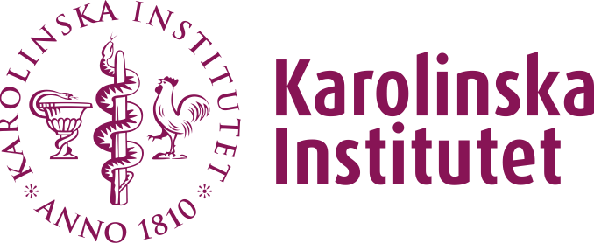

# DRAFT PROGRAMME SYLLABUS FOR

xxx (Name of the programme in English)

xxx (programmets namn på svenska)

## Essential data

**Programme code:** Text

**Name of the programme:** Text

**Number of credits:** Text

**Starting date:** Text

**Specific eligibility requirements:** Text

**Main field of study:** Text

**Qualification:** Qualification in English

*(Examensbenämning på svenska)*

A student who fulﬁls the requirements for the award of a qualiﬁcation shall, upon request, be provided with a certiﬁcate.

## Outcomes

### Outcomes According to the Higher Education Act

*(Remove objectives for the advanced level if the programme is at undergraduate level, and vice versa.)*

#### Outcomes of first cycle education according to the Higher Education Act

First-cycle courses and study programmes shall be based fundamentally on the knowledge acquired by pupils in national study programmes in the upper-secondary schools or its equivalent. The Government may, however, permit exceptions for courses and study programmes in the fine, applied or performing arts.

First-cycle courses and study programmes shall develop:

* the ability of students to make independent and critical assessments
* the ability of students to identify, formulate and solve problems autonomously, and
* the preparedness of students to deal with changes in working life.

In addition to knowledge and skills in their field of study, students shall develop the ability to:

* gather and interpret information at a scholarly level
* stay abreast of the development of knowledge, and
* communicate their knowledge to others, including those who lack specialist knowledge in the field.

#### Outcomes of second cycle education according to the Higher Education Act

Second-cycle courses and study programmes shall be based fundamentally on the knowledge acquired by students during ﬁrst-cycle courses and study programmes, or its equivalent.

Second-cycle courses and study programmes shall involve the acquisition of specialist knowledge, competence and skills in relation to ﬁrst-cycle courses and study programmes, and in addition to the requirements for ﬁrst-cycle courses and study programmes shall:

* further develop the ability of students to integrate and make autonomous use of their knowledge,
* develop the students' ability to deal with complex phenomena, issues and situations, and
* develop the students' potential for professional activities that demand considerable autonomy, or for research and development work.

### Degree Outcomes According to the Higher Education Ordinance

Text

### Outcomes of the Study Programme at Karolinska Institutet

Text

## Content and structure

*(Insert additional subheadings if required)*

Text

### Scientific knowledge, competence and approach

Text

### Practice Integrated Learning

Practice integrated learning is a generic term for the pedagogical models that are based on interaction and integration between higher education and working life. Practice integrated learning may take the form of work-based education, study visits, observing teaching activities or ﬁeld studies within out-patient and in-patient healthcare, social care or other relevant activities.

Text

### Cross-curricular perspectives

Text

### Elective courses

Text

## Other guidelines

### Grading scale

Text

### Language of instruction

Text

### Speciﬁc eligibility requirements within the programme

Text

### Cancellation of on-site training

A student's work-based education (VFU) can be immediately terminated if the student shows such serious deﬁciencies, in knowledge, skills or approach, that jeopardize patient safety or erode patient trust in healthcare. The administration of such matters must be outlined in the course syllabus. If work-based education is terminated this way, an individual action plan must be drawn up stating the actions that are required before the student is permitted to perform new workbased education.

## Study plan with constituent courses

### Semester. Course name. Credits. Main ﬁeld of study. Cycle

Text