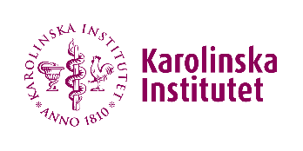
Checklist for PI´s/group leaders/supervisors
This document is intended for persons responsible for the systematic work environment in their group or for the work environment of employees/students.
New staff/students:
☐ Badge or Temporary card.
☐ Staff: Access to Office.
☐ Staff: Safety introduction, https://staff.ki.se/kis-laboratory-safety-introduction
☐ Students: Access to locker / Seat in touch-down areas.
☐ Code of conduct.
☐ Lab rules KI and ANA Futura.
☐ Next of kin.
☐ Introduction to the facilities and work environment (from lab coordinator or division coordinator). Provide access to the facility.
☐ All risk assessments related to work must be read.
☐ Fire safety introduction, specific for Ana Futura (1 hour with Marjan) or other facilities.
☐ Inform about rules and regulations regarding solitary work.
☐ Dress code for the lunchroom and offices.
☐ Liquid nitrogen course (if needed).
☐ Introduction to laboratories (given by room coordinators). Provide access to the laboratory.
☐ Introduction to instruments and methods.
Yearly check-ups or events, part of the systematic work environment:
☐ Performance dialogue.
☐ Fire safety training (3 hours).
☐ Updating and revision of all risk assessments (HUMRA, BARA, KLARA, others) together with group members.
☐ Exchanging chemicals to less dangerous ones if needed.
☐ Revise if solitary work needs to be conducted, follow guidelines if needed (individual risk assessments).
☐ Meeting about work environment with group.
☐ Repeat courses if needed: laboratory safety test and fire safety training (every 4th year).

